David Raymond

CSCIE-118

Card Trader QuickStart guide

Table of Contents

Overview: 2

The Application 2

Manage Card Series 4

Card App (Card Owner/Trader Application) 10

Appendix II - Trade Request Workflow Diagram 16

## Overview:

The Card Trader application is a proof-of-concept (POC) that allows people to trade virtual trading cards. The Card Trader applications supports both card creators and card traders. Card Trader allows card creators to create new Card Series contracts. Card Series contracts are containers that is used to contain cards that are in some way related from the creator’s perspective e.g. “Marvel Villain Trading Cards for 2018”. Once a Card Series contract is created the manager of the Card Series can add new cards to the contract. This does require that the cards are associated with their owners when added. Card Series creators can create many Card Series contracts and they can manage each of them and can see the trading requests that are being created for each of the series they own. Card Trader also supports card owners. Card owners can view all the Card Series they own cards for, they can drill into each of the Card Series to view they cards they own and make a Trade Request. A Trader Request is made up of the owner (requestor) that wants to trade their card and the card they want to trade chosen from a list of cards they don’t already own. Once a Trader Request is made the owner of the card that requestor wants to trade for is found within the card series contract and added as the requestee to the Trade Request. The requestee can then Approve the trade or Decline the trade. If the requestee approves the trade, then the card ownership is swapped, and the trade is completed. If they decline than the trade is declined, and the cards are not swapped between owners. Once a Trade Request is either approved or declined it is completed and cannot be used further (see Appendix II for a Trade Request Workflow Diagram).

## The Application

***URL to Use in the Chrome Browser to Load the Card Trader Application in the Chrome browser:***

[**http://104.248.238.170:3000**](http://104.248.238.170:3000)

The CardTrader application has a very simply UI that has a landing page that has two Navigation buttons, Manage and Card App.

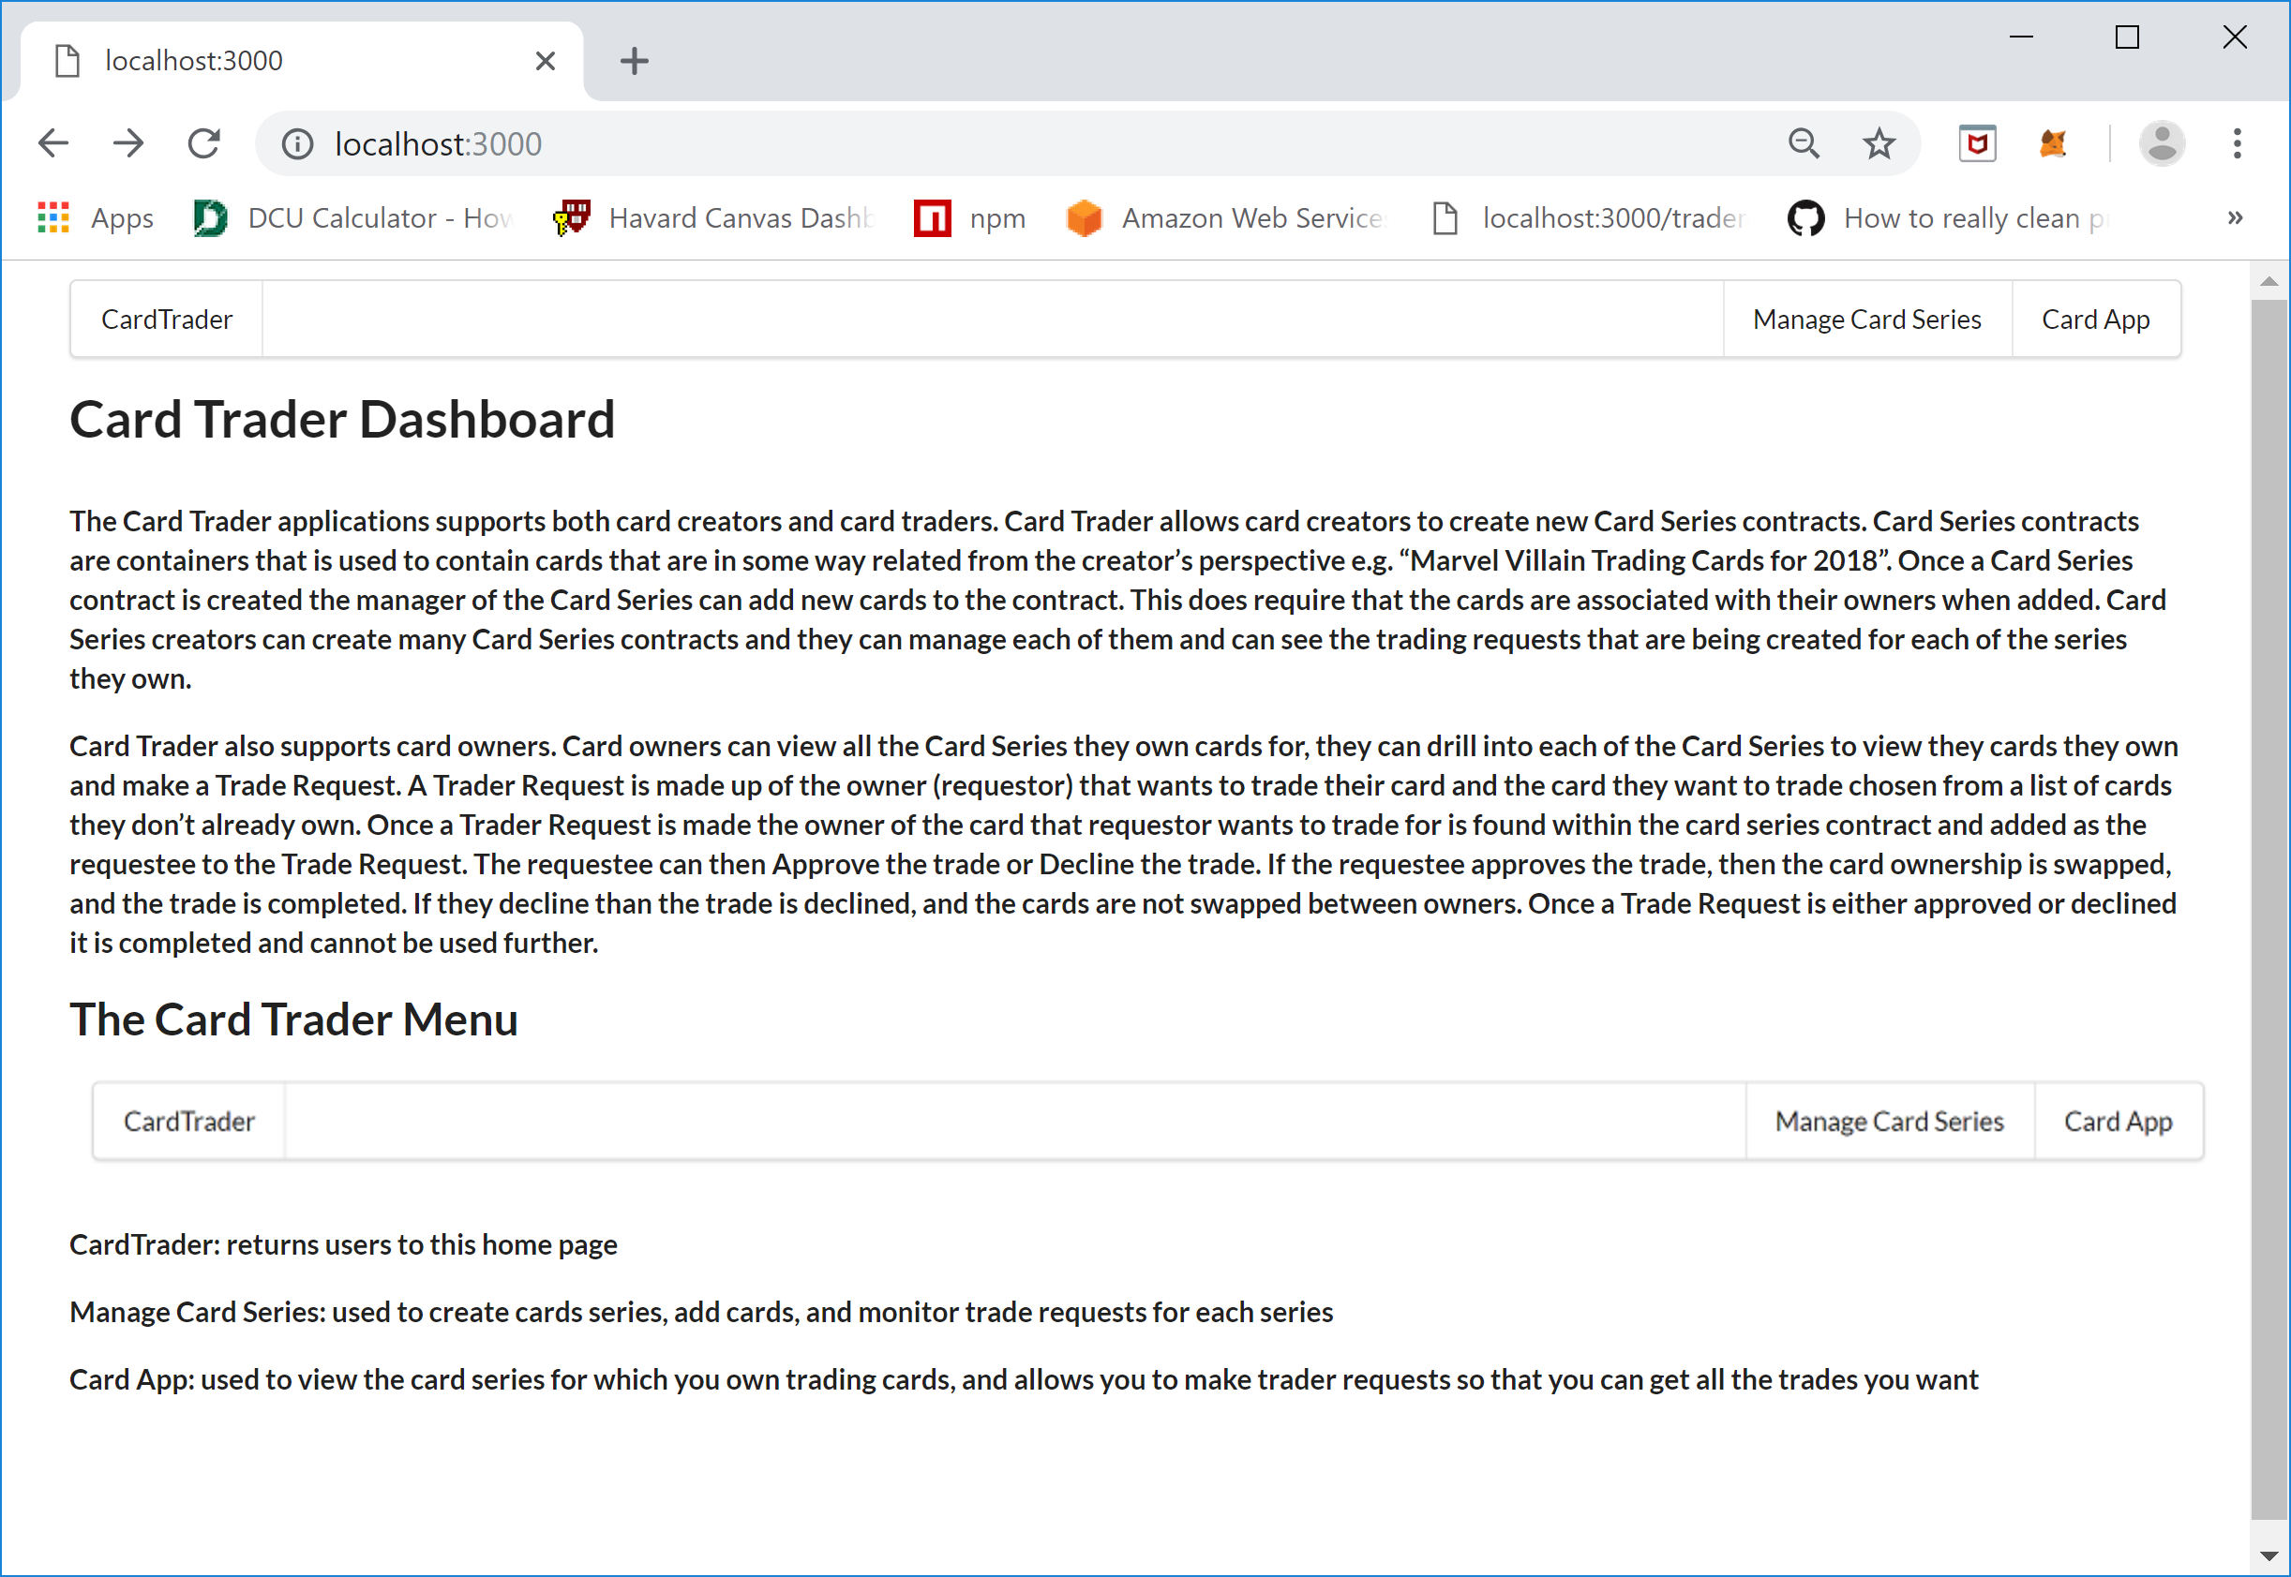

The menu items at the top the Card Trader Dashboard is as follows:



The “Card Trader” menu item brings you back the homepage, the “Manage Card Series” item allows card creators to create new Card Series contracts, provision trading cards, and monitor trading requests for a specific card series. The “Card App” menu item allows card owners to see the Card Series contracts for which they have Trading Cards for and to create Trade Request. When you click either “Manage Card Series” or “Card App” will request you to login to MetaMask if the user is not already logged in.

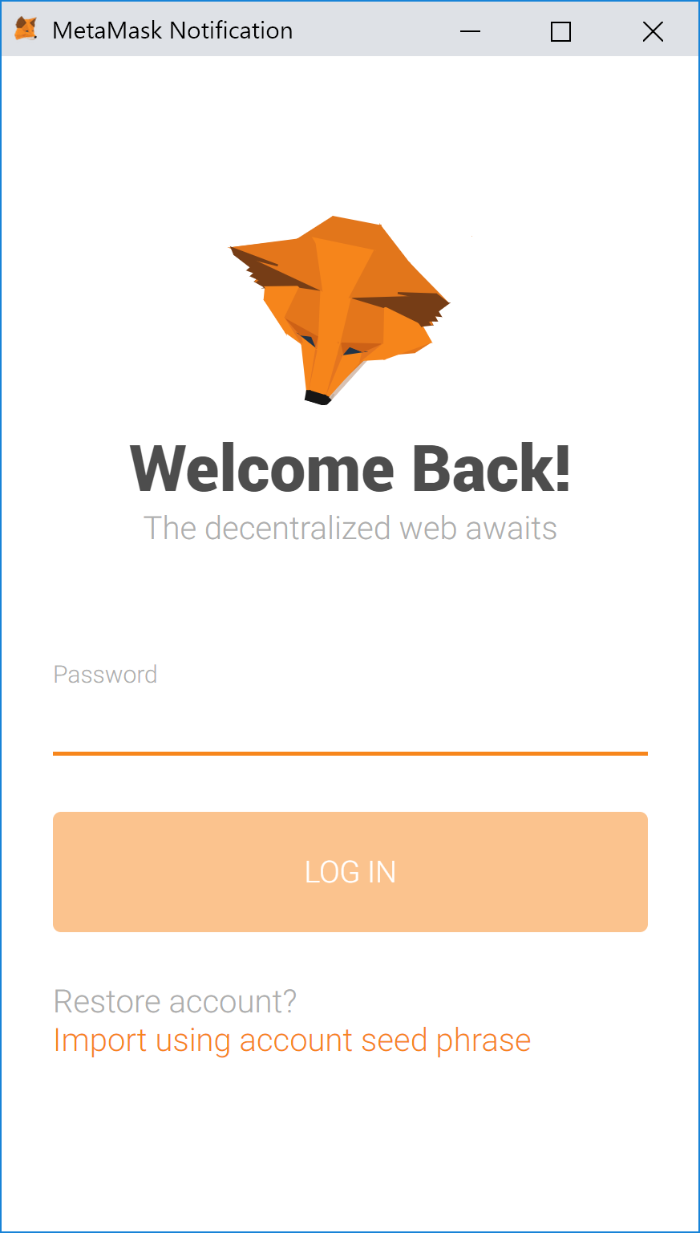

Also, clicking either choice will bring up a MetaMask wallet request to allow the Card Trader application to connect to it. If you see this message, please click the Connect button so that the application can interact with the MetaMask wallet.

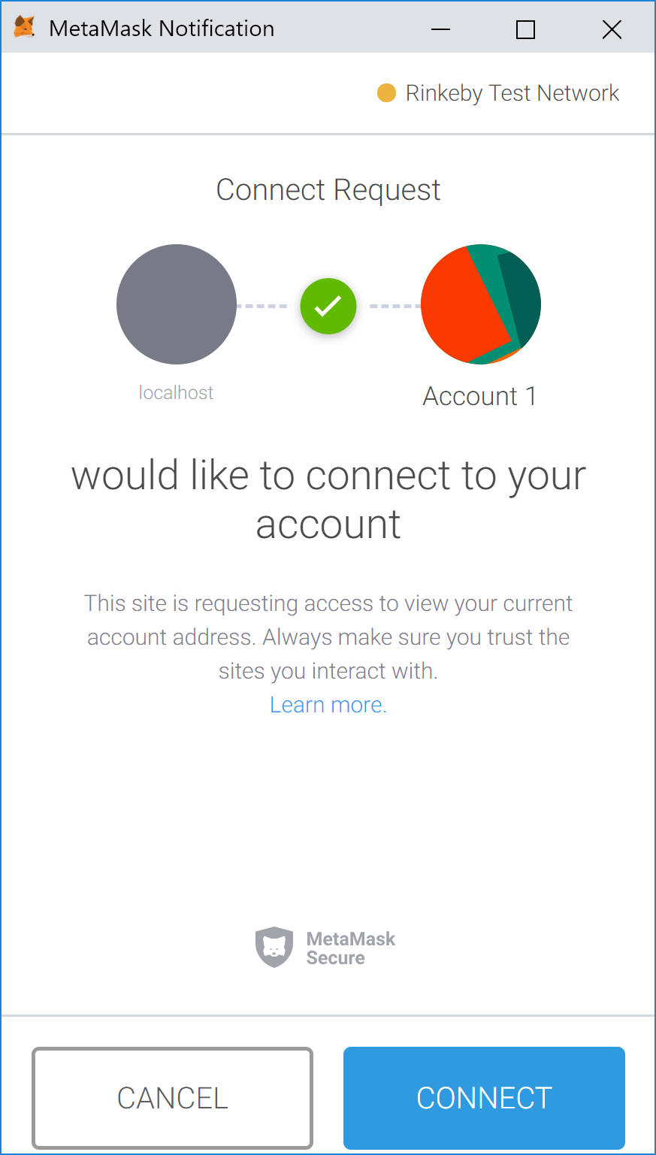

### Manage Card Series

Once you are logged into your MetaMask wallet and you have allowed the Card Trader application to connect to the MetaMask wallet you will see the following screen if you haven’t created any Card Series yet.

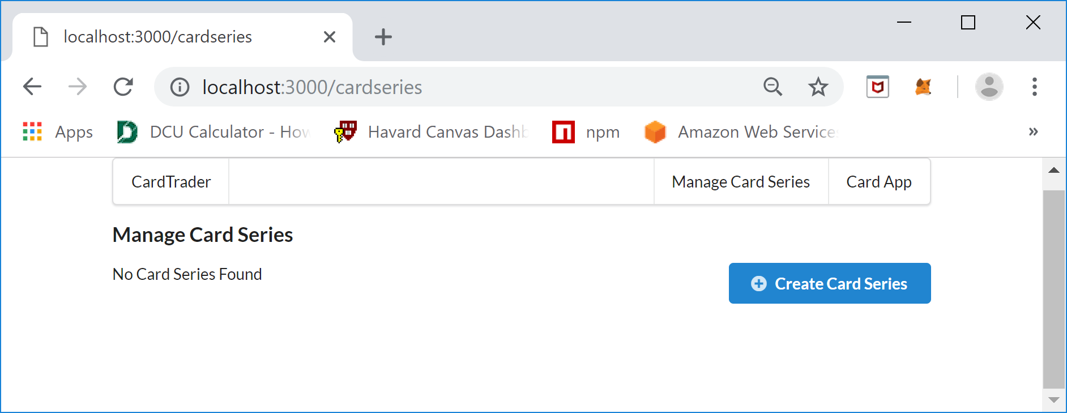

The first thing you want to do as a Trading Card creator is to create a Card Series to hold all the Trading Cards you are issuing. To achieve this, click the “Create Card Series” button an you will see the following Card Series form screen:

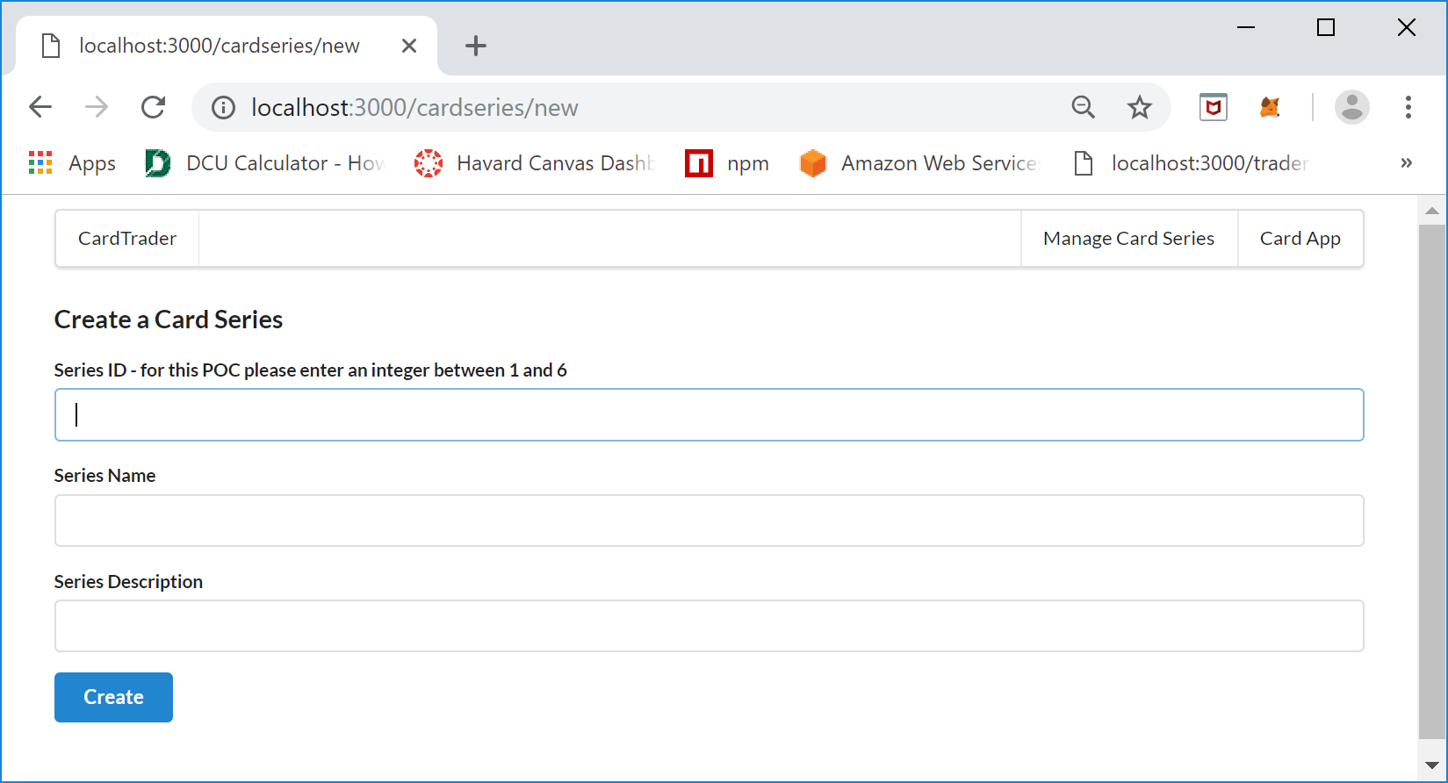

On this screen creators create a Card Series by entering a Card Series ID, Series Name, and Series Description. The Series ID must be an integer value that will be used as a key to retrieve the details of the Card Series after it is created, the Series Name is a friendly name that you wish to display to the user, and the Series Description is a detailed description of the Card Series that describes the type of Trading Cards the Card Series contains. An example of a valid entry is as follows:

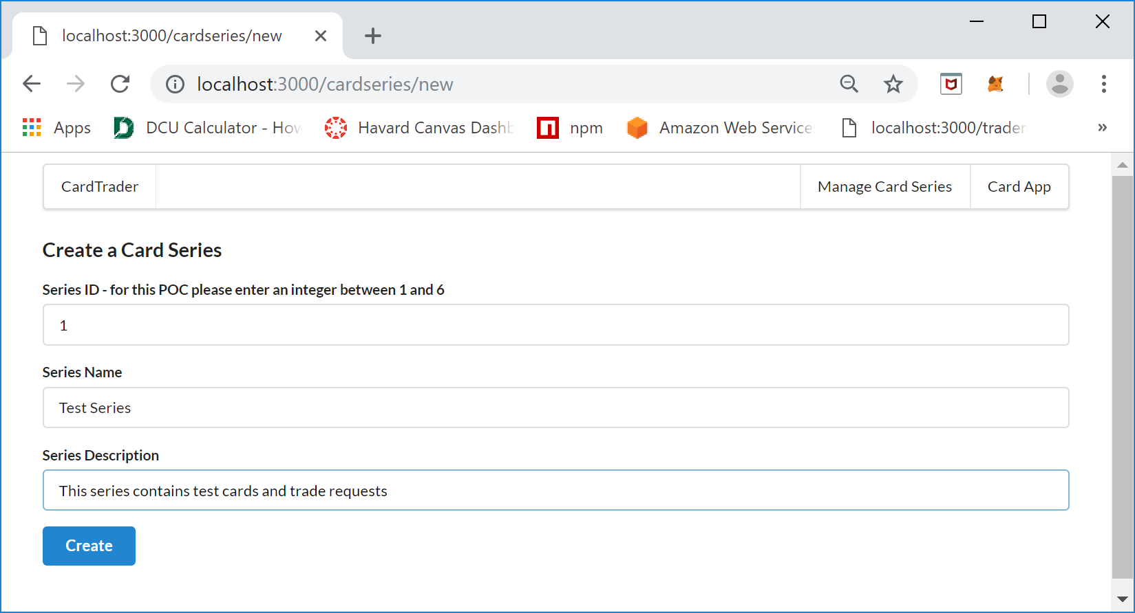

Click the “Create” button to create the Card Series. Once you click the Create button you will see the following MetaMask screen confirming that you want to process the request to the blockchain and pay the gas charges:

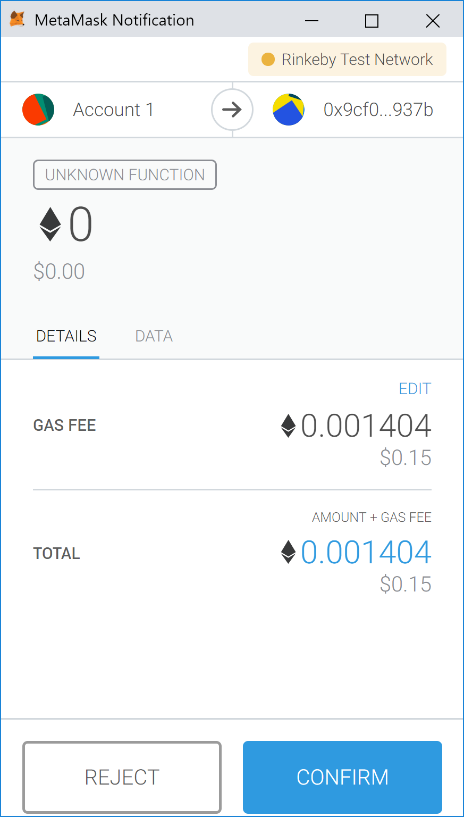

Click “Confirm” to continue to create the Card Series. Once the processing of the request is complete you will be brought back to the “Manage Card Series” screen and the new Card Series should be listed, if it isn’t please clicking the browser Reload button, occasionally the screen doesn’t refresh properly.

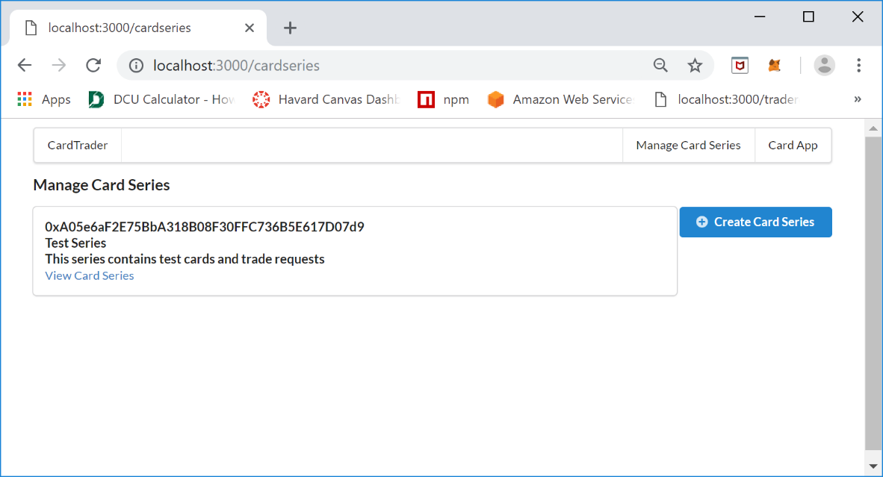

The “Manage Card Series” screen shows a list of the Card Series that have been created by the owner associated with the MetaMask address used to create the series. The list shows the Card Series address and a link “View Card Series” that allows you to see a summary of the Card Series, View Trade Requests, and add Trading Cards. The next step is to add Cards to the Cards Series. To do this a creator clicks the “View Card Series” link and you will see the following screen:

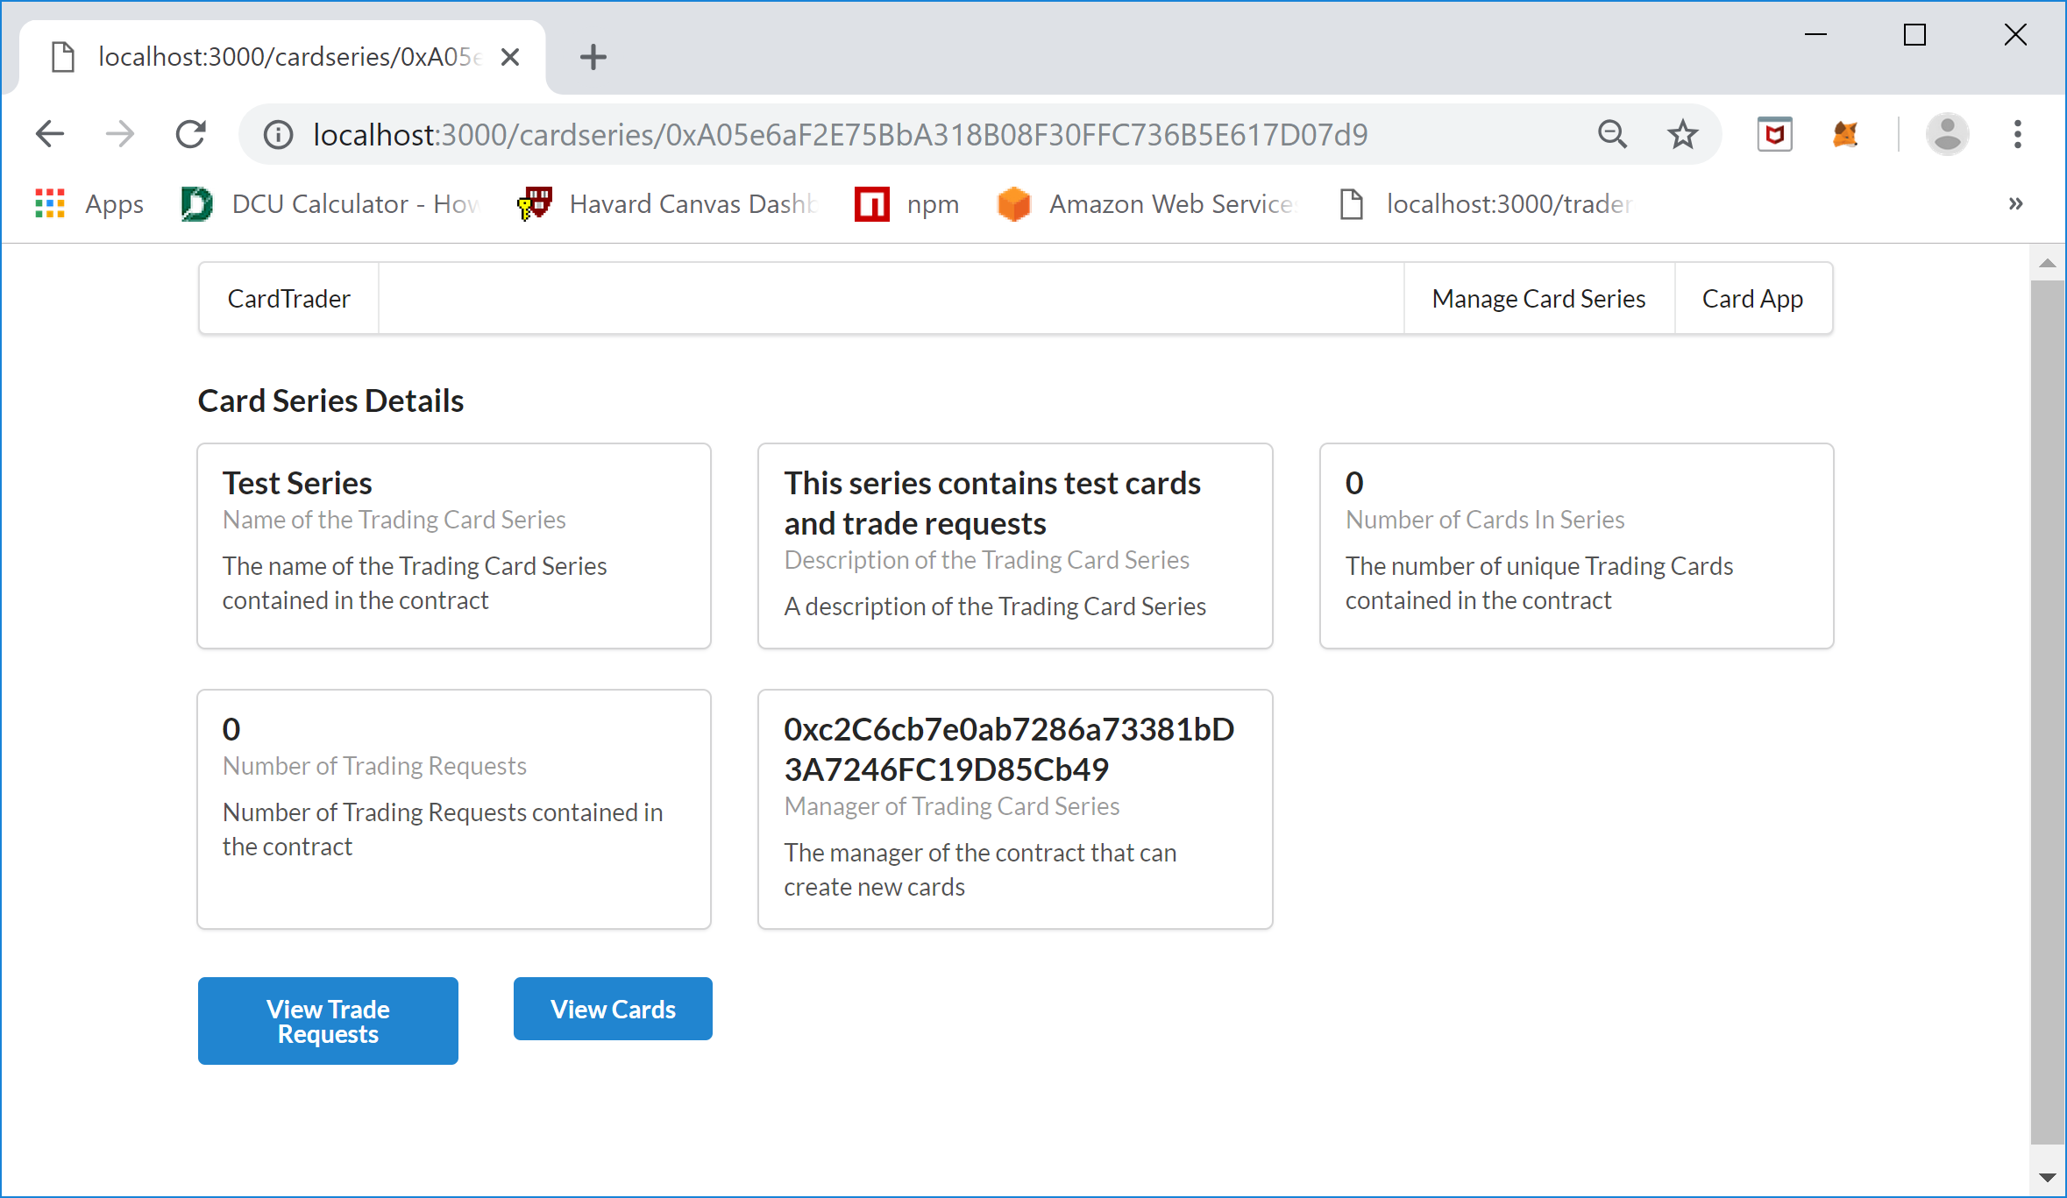

The “Card Series Details” screen allows you to see the Card Series contract details as well as to view the Trade Requests and Cards that are contained within the Card Series Contract. The next step for a creator is to add new cards to the Card Series Contract, to accomplish this click the “View Cards” button and you will see the following screen:

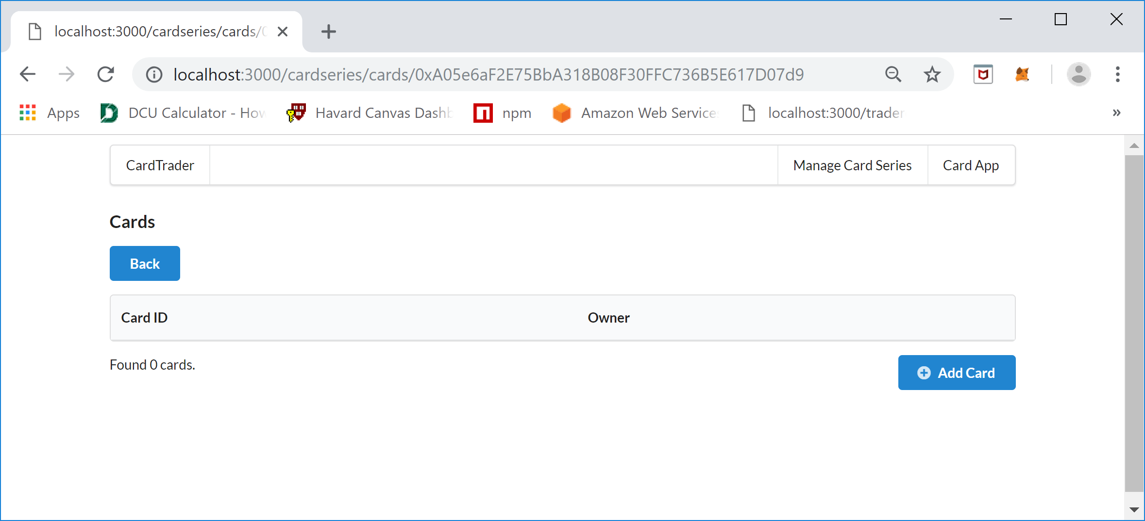

Since this is a newly created Card Series there are no cards contained within it yet. To create a new Card, click the “Add Card” button and you will see the following screen:

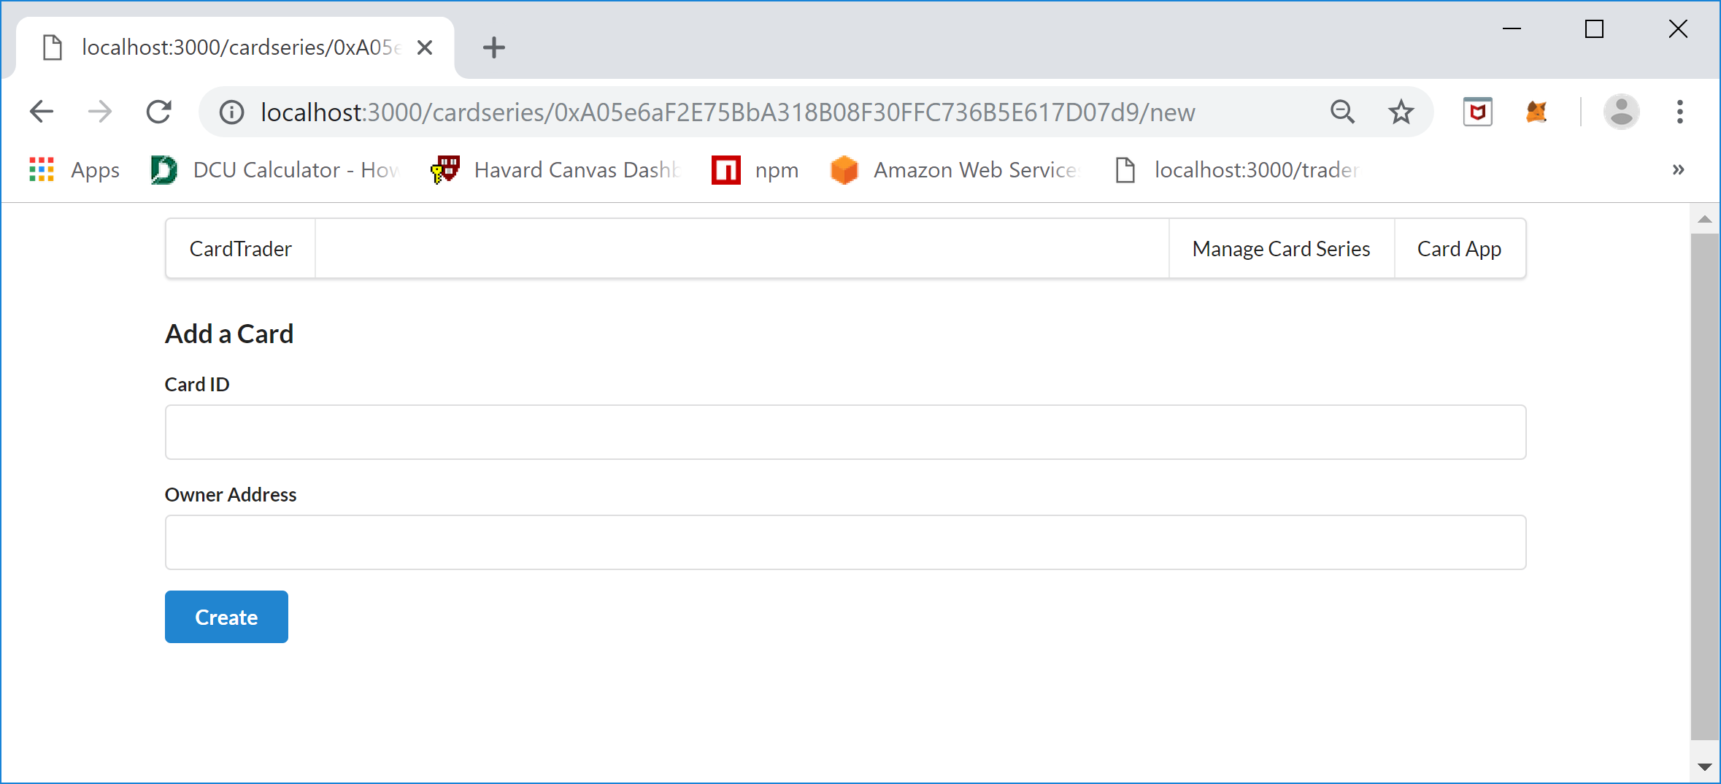

The “Add a Card” screen requires a Card ID that is unique within the Card Series and the Owner Address. The Card ID is an integer value and the Owner Address is the wallet address of the card owner not the creator but the owner of the card. For this proof of concept application, the creator should only create up to six cards and should use the card id’s 1 thru 6, also for the proof of concept the owner oft the cards can also be the manager. For testing you will want to use two different MetaMask account addresses to represent two different users that can trade cards between each other, but you must add the cards as the Manager which is the MetaMask wallet address that created the Card Series. The following is an example of adding a card:

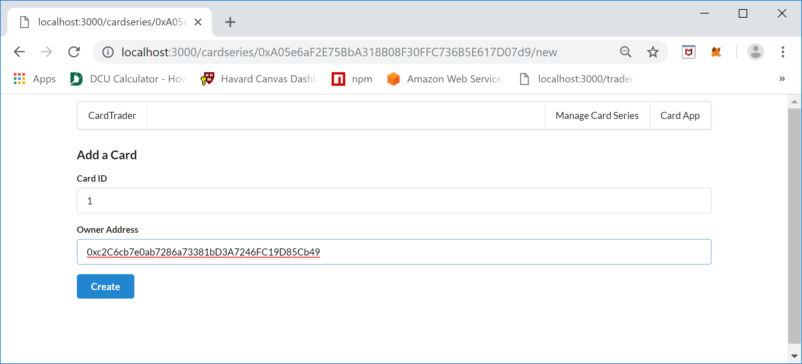

Once the Create button is clicked you will again see a MetaMask Notification screen asking to REJECT or CONFIRM the transaction, to proceed click the CONFIRM button. Once the transaction is processed the following screen will be displayed listing all the Cards created so far in the series.

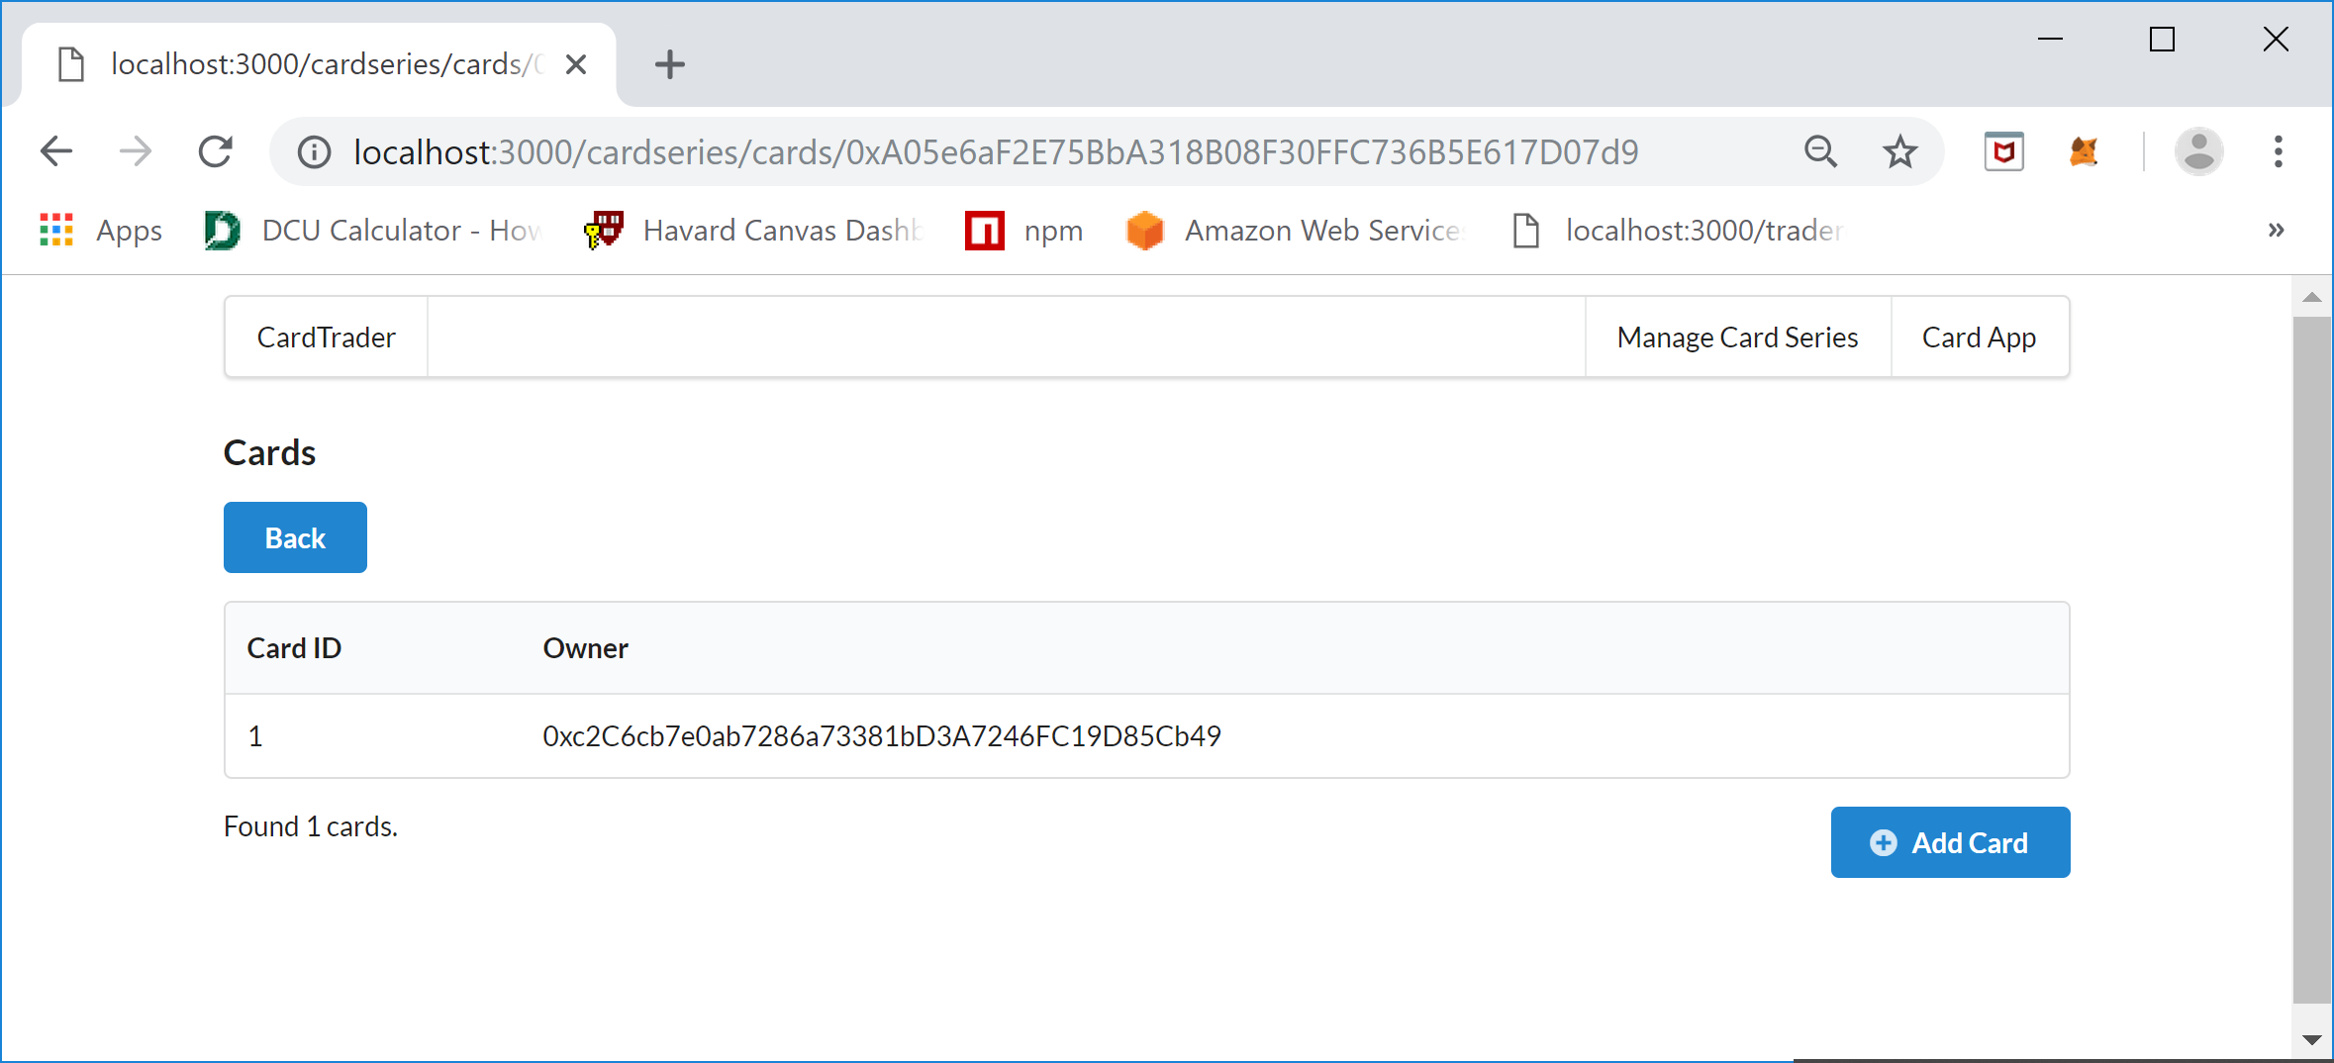

The manger of the Card Series will than add all the Cards they want to the Card Series. For demonstration purposes the following cards were added.

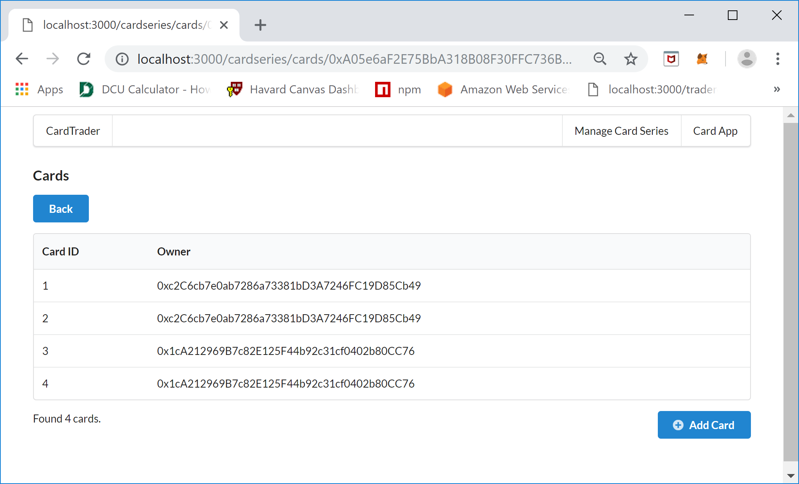

The next step is to check the Card Series Details to see a summary of what has been done so far, to do this click the back button and you will again see the Card Series Details screen:

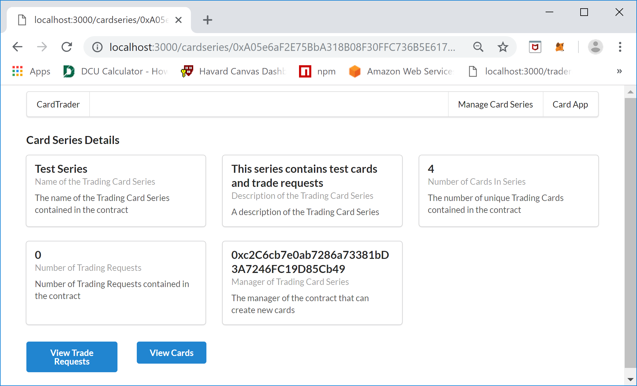

After adding the cards for the Card Series, the Card Series Detail screen will have the number of cards changed to reflect the number of Trading Cards added to the Card Series Contract. The next step is to switch over to the Card owner view of the contract by clicking the “Card App” menu item in the upper right of the screen.

### Card App (Card Owner/Trader Application)

Once the “Card App” menu item is clicked at the top right using a MetaMask account address that you have assigned Trading Cards to a Card Series you will see the following screen:

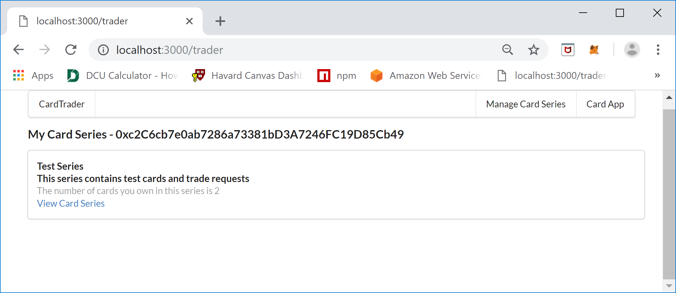

The “My Card Series” screen shows the Card Series where there are Trading Cards assigned to the currently selected MetaMask Wallet Account Address. The number after the “My Card Series – “ is the current MetaMask Wallet Account Address. For each Card Series you will see the Series Name, Series Description, the number of cards you own and a link to view the cards. Click the “View Cards Series” link to see the Trading Cards associated with the account and the following will be display:

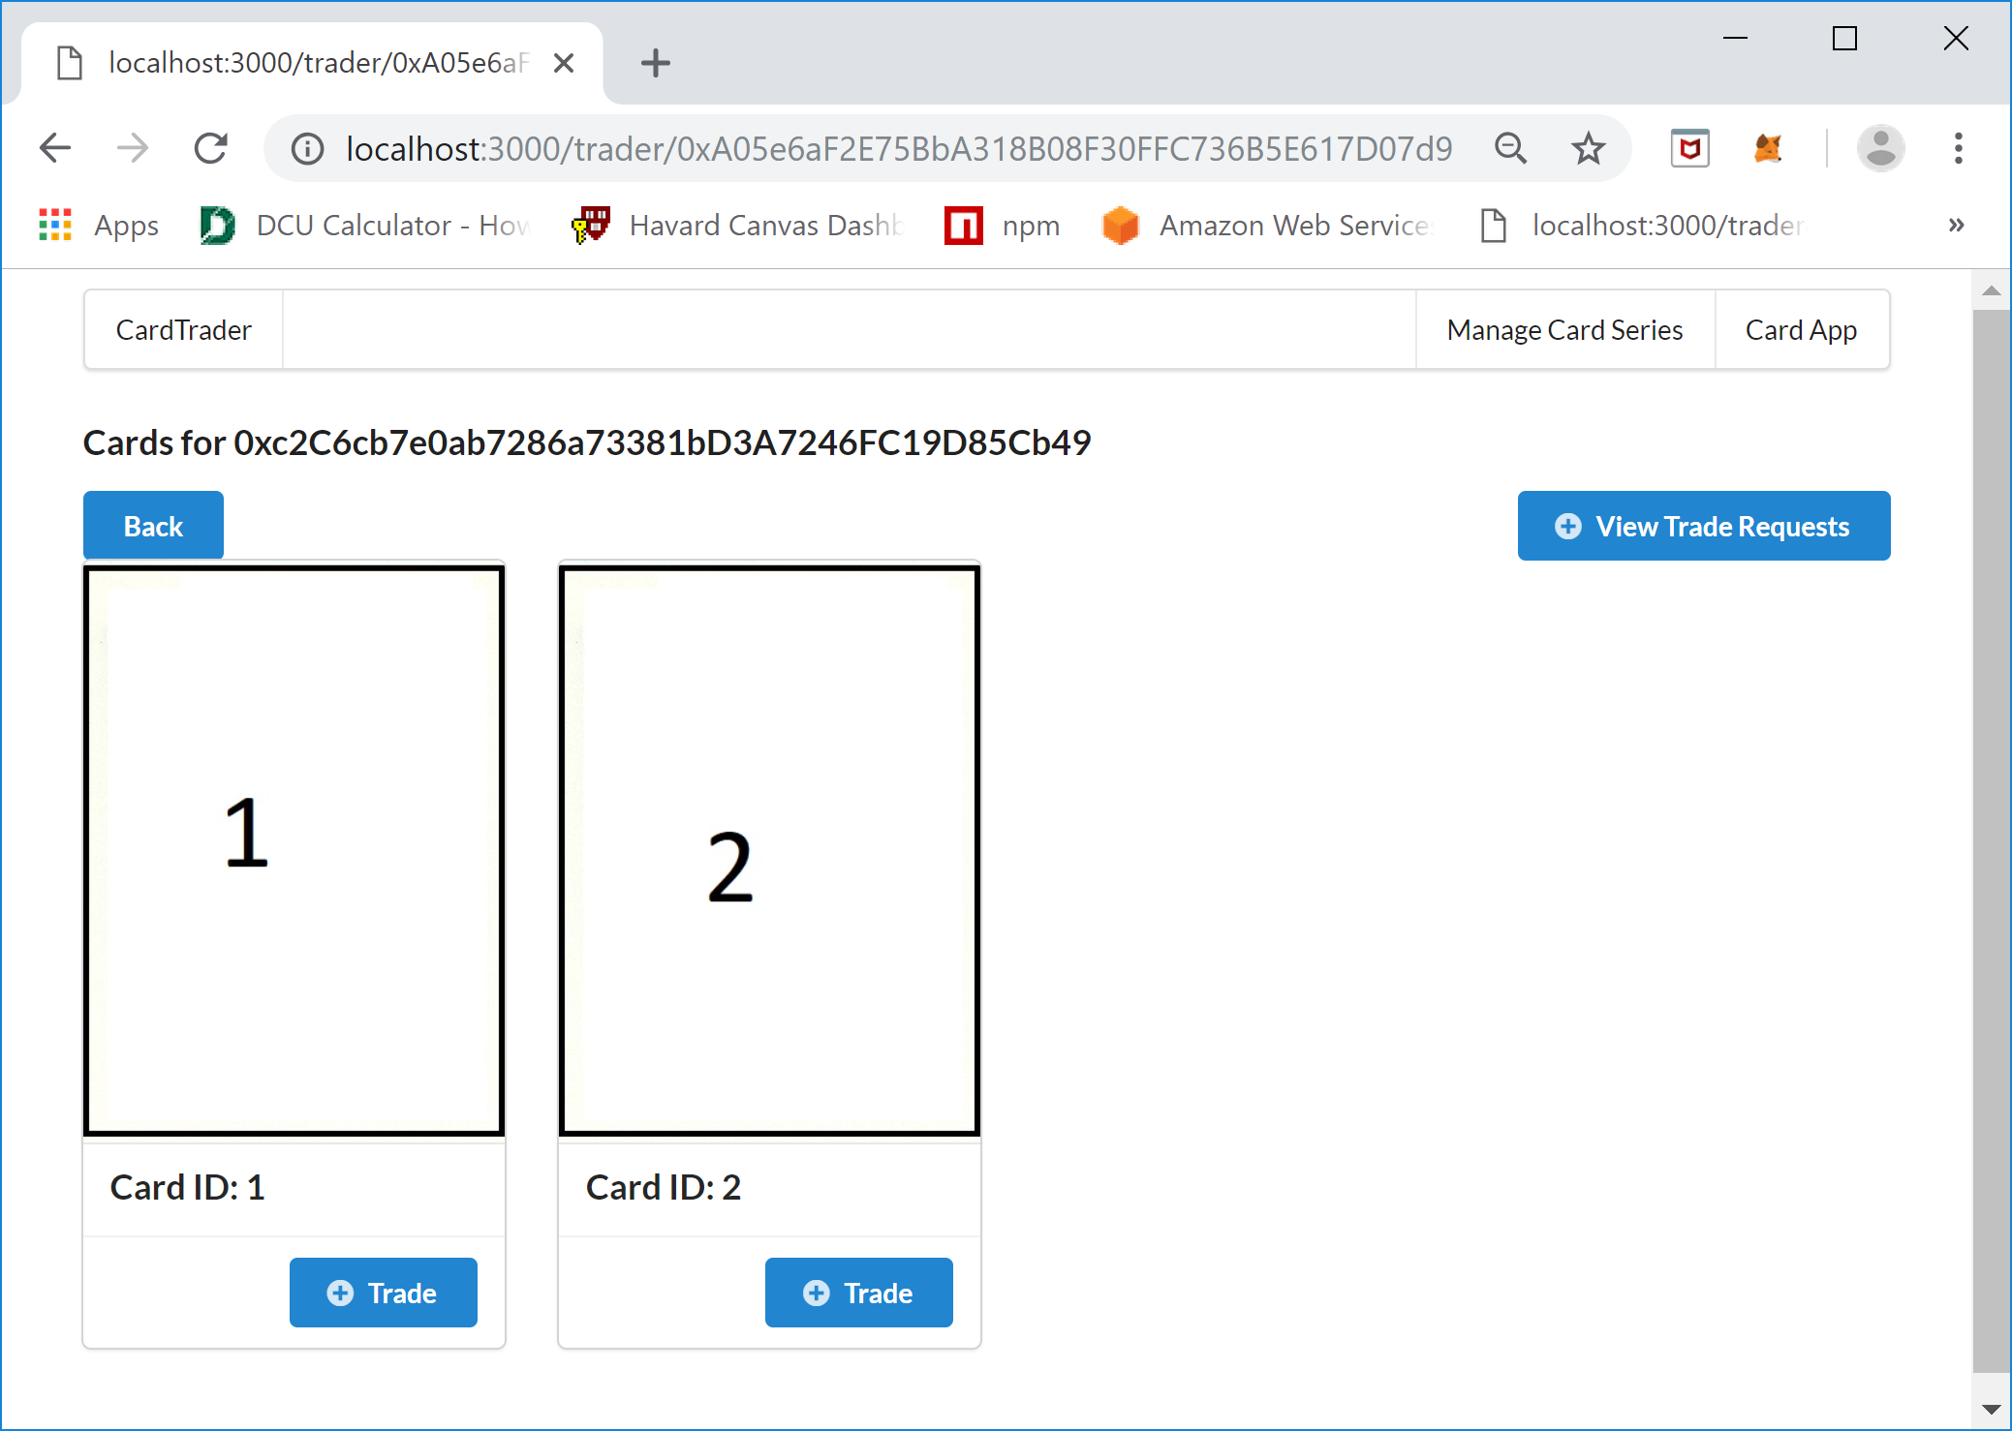

This Cards screen shows the cards for the currently selected MetaMask Wallet Account address. The number after the “Card for “ is the Wallet Account Address that is being used to retrieve the Trading Cards that are owned by the account. From this screen you can view the trade requests that are associated with the selected account and a Card can be selected to create a Trader Request to trade a card. For example, to Trade the 1 Card with Card ID 1 the Trade button is clicked under the card. Once the Trade button is clicked the following screen will be displayed:

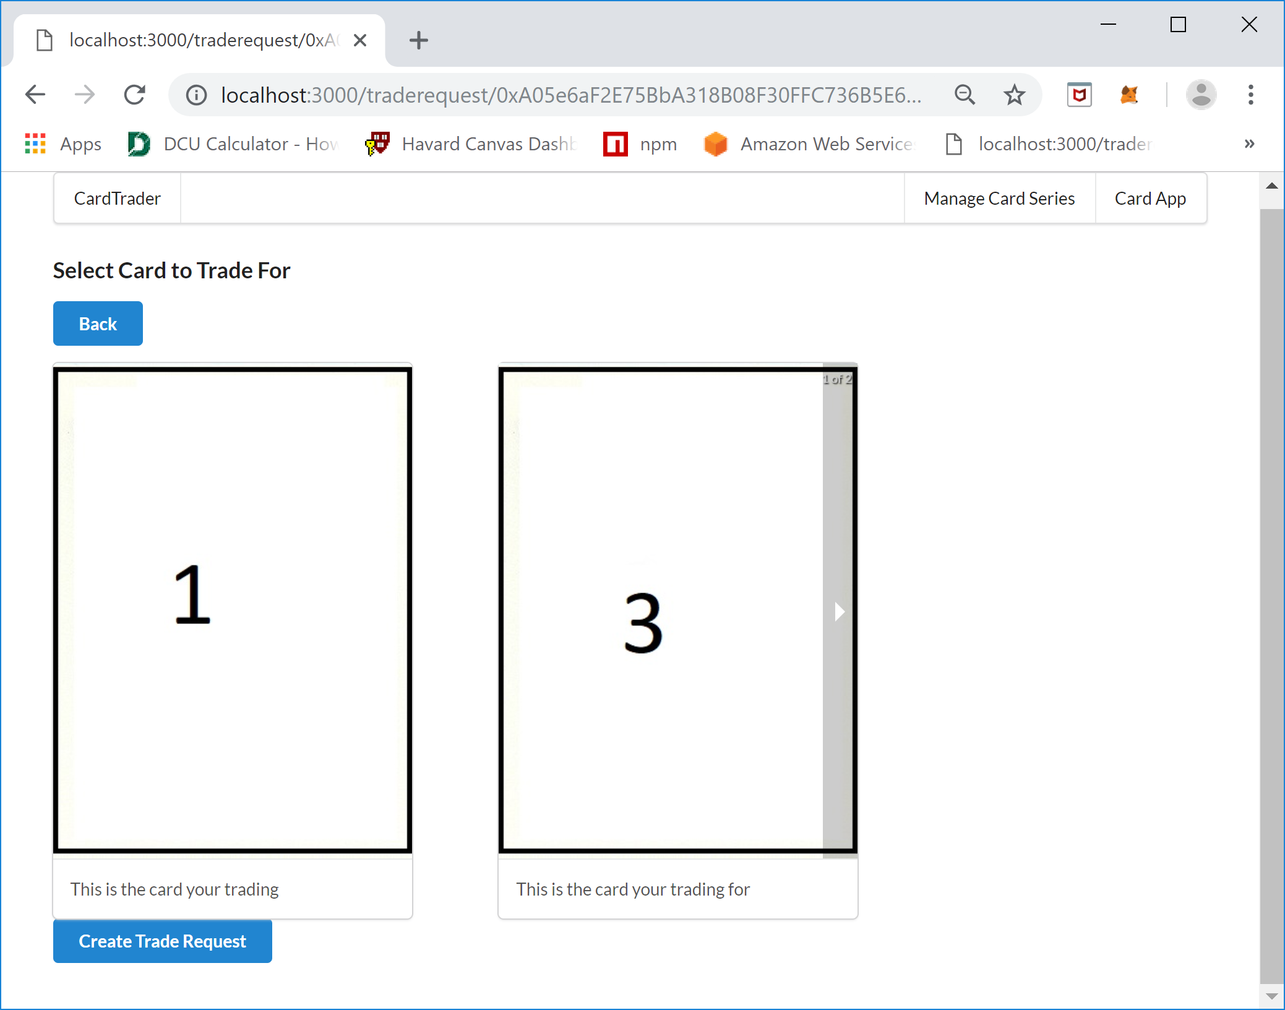

On the “Select Card to Trade For” screen you will see the card that is already owned by the account on the left and the card to trade for that isn’t owned by the current account on the right. Notice that there is an arrow bar on the edge of the card to trade for, the cards to select are loaded in a carousel control and you can iterate over the cards by hovering over the right or left edge of the card and clicking he arrow bar.

Here is a more detailed view of how the carousel control works:

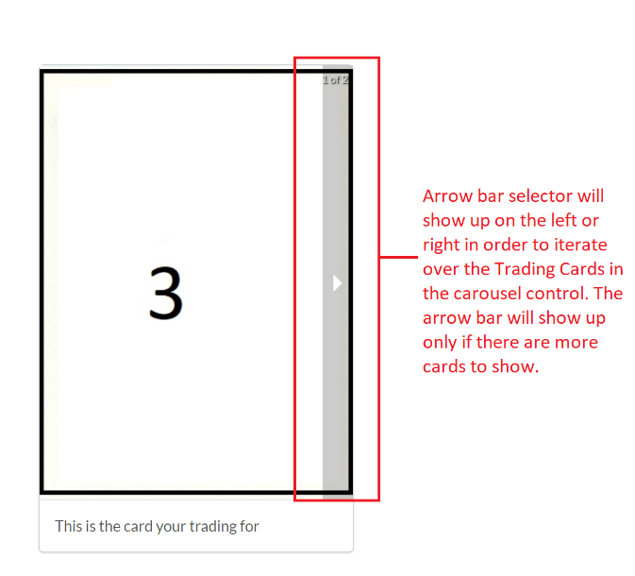

It is important to note that the arrow bar will show on the right to move forward through the list of cards and on the left when going back through cards. Once the desired Trading Card is found to trade for the owner then clicks the “Create Trade Request” button at the bottom left of the screen to make a Trade Request. A MetaMask Notification screen will display click CONFIRM to continue and create the Trading Request, the following screen should be seen when complete:

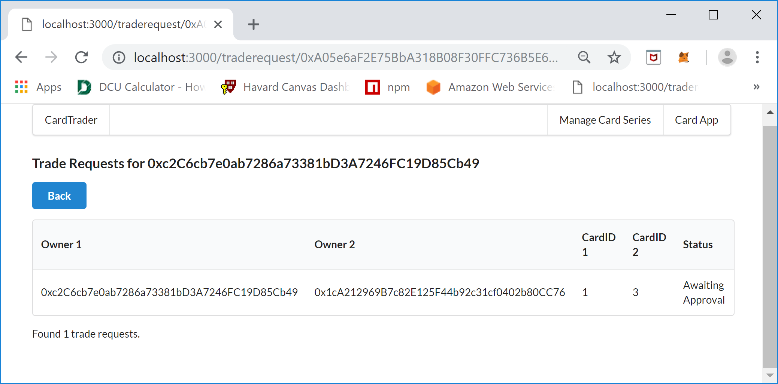

This is the Trade Requests screen, the number after the test “Trade Requests for “ is the current MetaMask Account. On this screen there will be a list of Trade Requests made by the current account and will show Owner1, Owner2, CardID 1, CardID 2, and Status of the Trade Request. Owner1 is the owner of the card that is making the Trader Request and will be called the requestor, CardID 1 is the card that the requestors card that they want to trade, Owner 2 is the owner of the card the requestor wants to trade for and CardID 2 is the card that the requestor wants to obtain and is called the Requestee. The Status is the stage or state of the Trade Request. The requestor submits the Trade Request but the owner of the card the requestor wants to trade for is the approver of the Trade Request and can either Approve or Decline the request. In order to see the Requestee’s view you will need to switch the currently selected MetaMask account to the Requestee’s account and refresh the screen or click the Card App menu item and navigate to View Trade Requests. Here are the steps, first select the Requestee account in MetaMask:

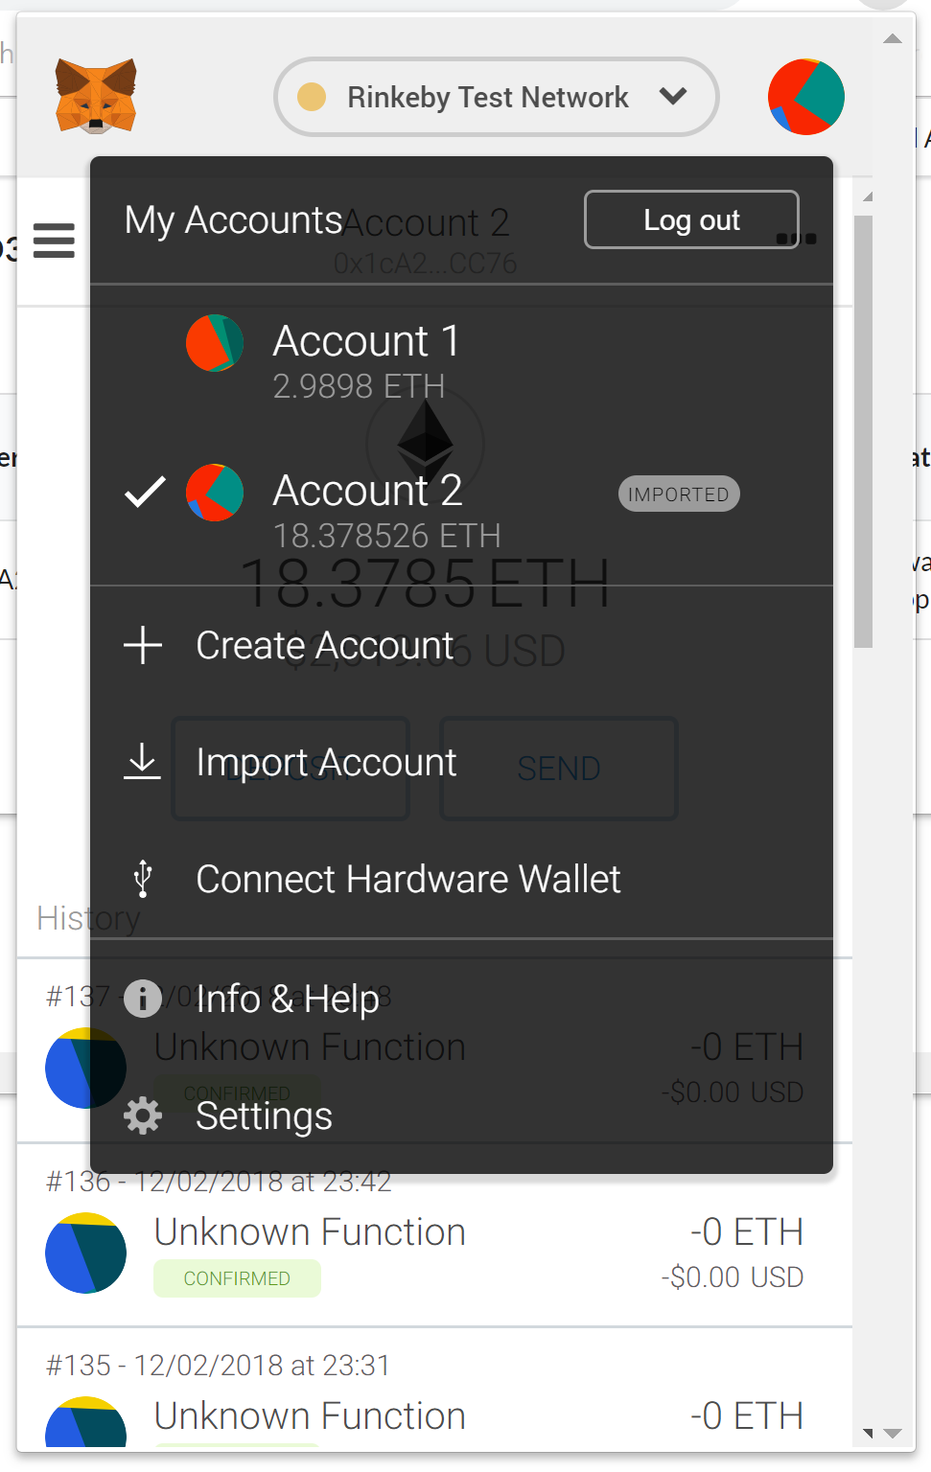

The refresh the “Trade Requests” screen and you should see the following screen:

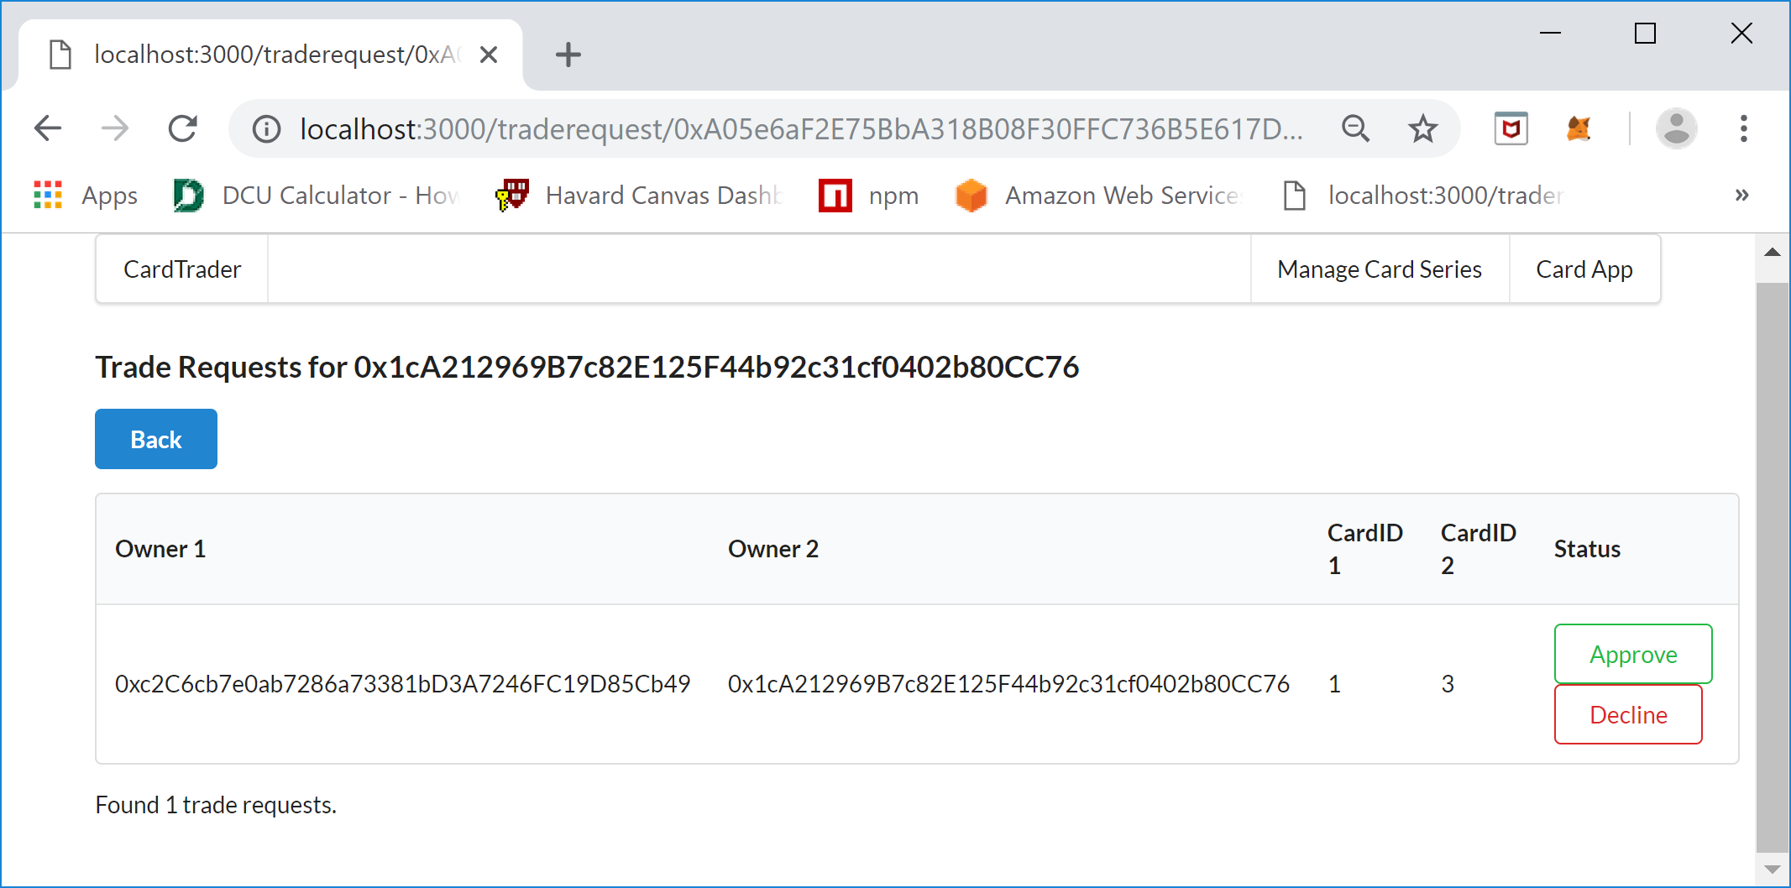

The Requestee’s view of the screen shows that the owner of the card that Request (owner1) wants to trade for shows an Approve and Decline button. If the Requestee (owner2) Declines the Trade Request than the status of the TradeRequest changes to Declined and the workflow for the trade ends. If the Requestee Approves the request then the Trade Request is carried out , the ownership of the cards is swapped and the Trade Request status changes to Completed. For example, the Approve button will be clicked, MetaMask will ask to CONFIRM the request and pay the gas and the transaction will be attempted. The Trade Request screen should refresh, sometimes this fails and requires a manual refresh, and the status of the Trade Request will be updated to Completed, the following should be displayed:

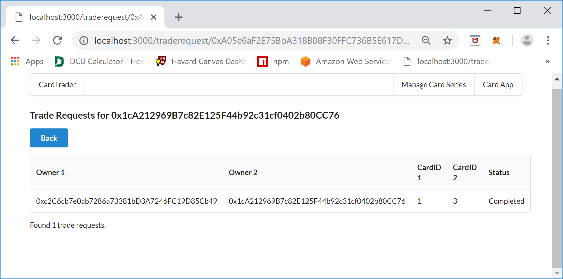

If the Trade Request worked then the cards owned by the Requestee will go from Card ID 3, and 4 to Card ID 1, and 4. To view this click the Back button to go back to the Cards screen:

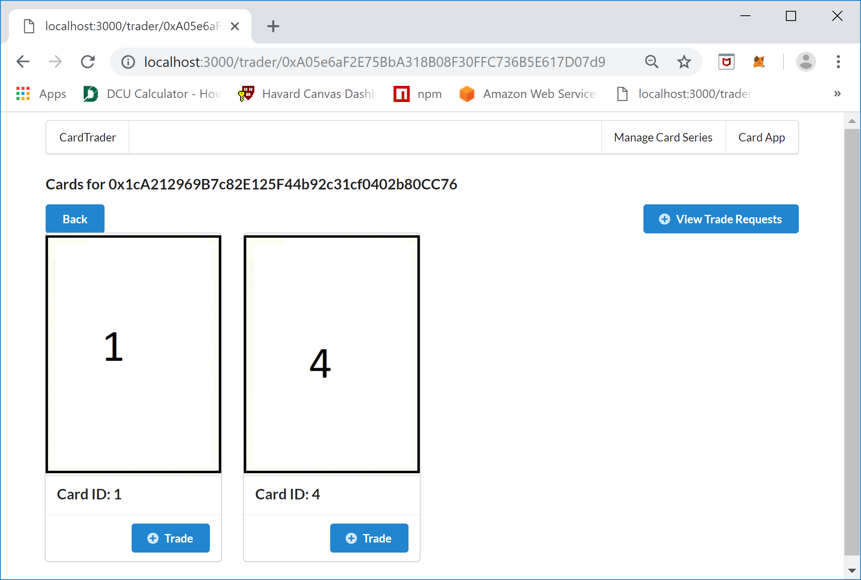

And the Requestor (owner1) should now own cards with Card ID’s 2, and 3. To prove this switch the MetaMask account back to the Requestor and then refresh the screen:

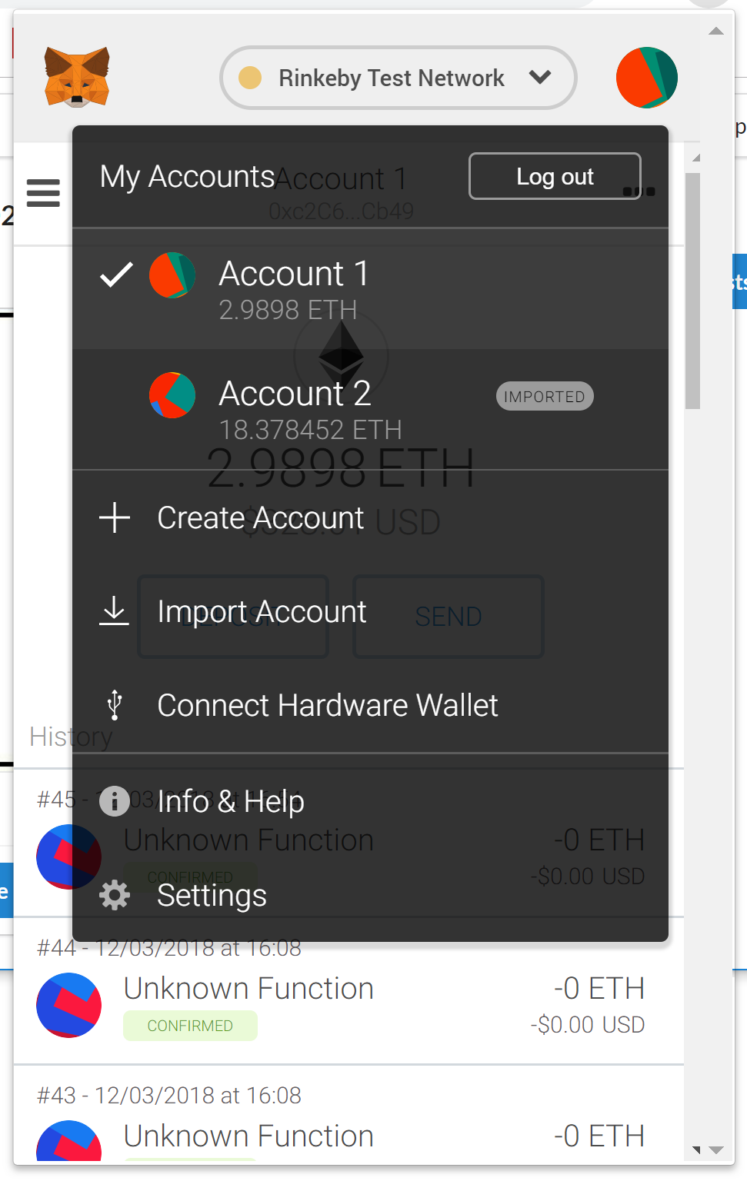

Then refresh the screen and the following should be displayed:

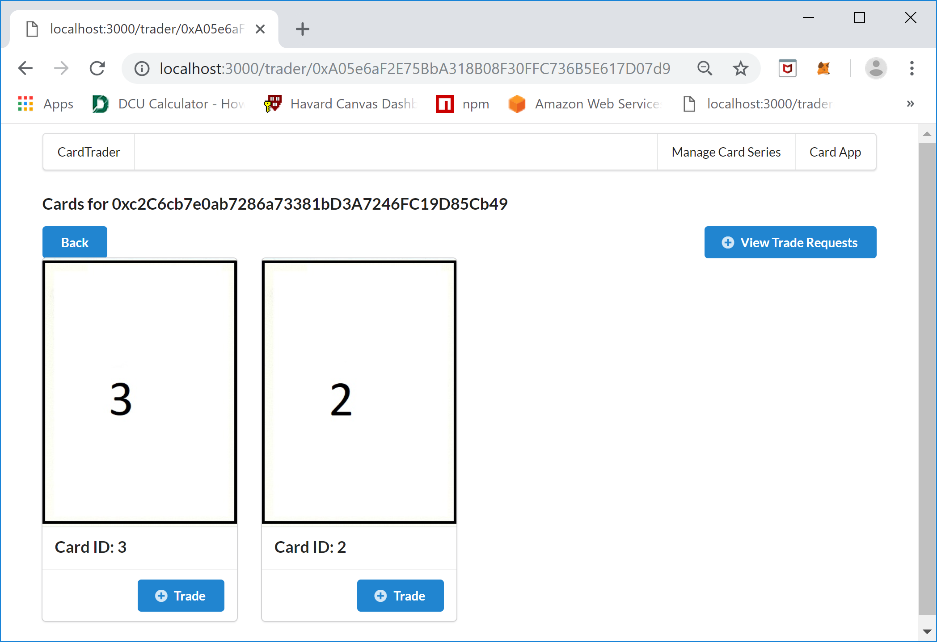

The Cards screen for the Requestor (owner1) is correct and the Trade Request was carried out.

## Appendix II - Trade Request Workflow Diagram

